TCUP 2009 – Místní propozice – příloha č. 2

HRANICE SOUTĚŽNÍ OBLASTI TOUŽIM CUP 2009

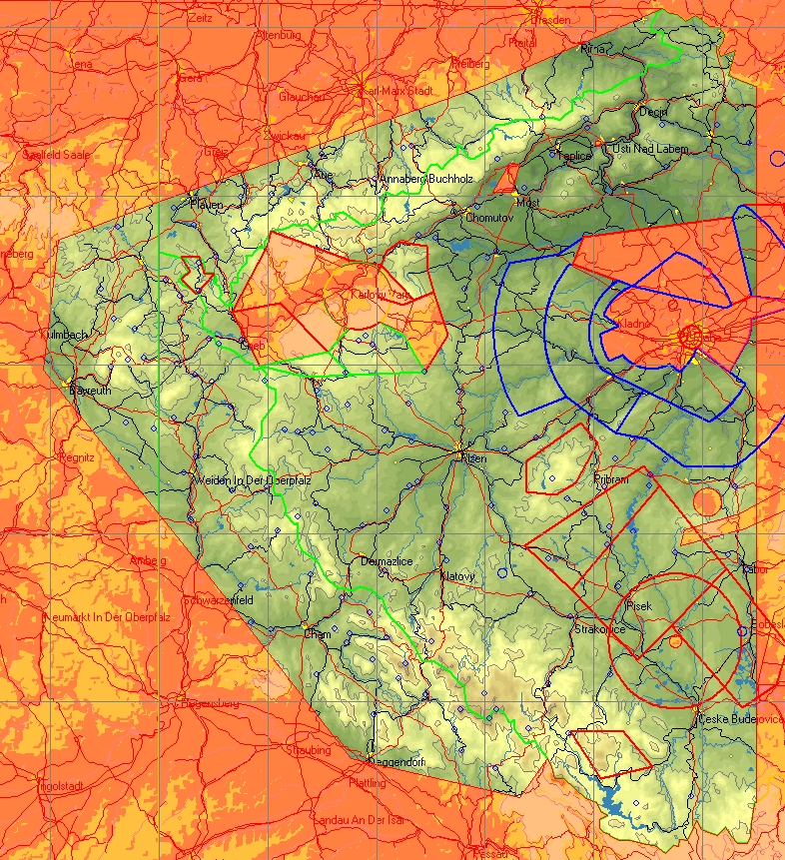

AC P
AN TOUZIM CUP2009 (TCUP2009)
AH FL999
AL GND
*Frame
DP 51:05:00 N 011:00:00 E
DP 51:05:00 N 015:30:00 E
DP 48:30:00 N 015:30:00 E
DP 48:30:00 N 011:00:00 E
DP 51:05:00 N 011:00:00 E
*Frame
*Border
DP 51:03:24 N 014:19:04 E *CZ North Point
DP 51:03:10 N 014:18:34 E
DP 50:49:46 N 013:29:50 E
DP 50:28:42 N 011:58:54 E
DP 50:22:12 N 011:32:05 E
DP 49:59:04 N 011:28:00 E
DP 49:23:13 N 012:12:39 E
DP 48:49:52 N 012:52:53 E
DP 48:43:06 N 013:39:25 E
DP 48:49:42 N 013:47:04 E
DP 48:49:56 N 013:47:11 E
DP 48:48:20 N 013:48:23 E
DP 48:46:24 N 013:49:09 E
DP 48:46:20 N 013:51:33 E
DP 48:42:49 N 013:57:51 E
DP 48:42:07 N 014:00:43 E
DP 48:40:36 N 014:02:00 E
DP 48:39:53 N 014:03:45 E
DP 48:39:07 N 014:01:34 E
DP 48:37:34 N 014:01:44 E
DP 48:36:46 N 014:02:42 E
DP 48:36:25 N 014:04:17 E
DP 48:36:00 N 014:04:35 E
DP 48:35:21 N 014:07:01 E
DP 48:35:24 N 014:09:58 E
DP 48:34:40 N 014:14:23 E
DP 48:34:27 N 014:16:41 E
DP 48:33:07 N 014:19:45 E *CZ South Point
DP 48:33:54 N 014:21:15 E
DP 48:34:25 N 014:22:04 E
DP 48:34:16 N 014:23:26 E
DP 48:35:38 N 014:23:34 E
DP 48:35:18 N 014:25:58 E
DP 48:36:45 N 014:27:05 E
DP 48:37:39 N 014:27:31 E
DP 48:38:51 N 014:28:17 E
DP 48:37:23 N 014:29:42 E
DP 48:36:52 N 014:31:41 E
DP 48:36:12 N 014:34:02 E
DP 48:37:36 N 014:36:25 E
DP 48:36:10 N 014:38:01 E
DP 48:34:51 N 014:39:44 E
DP 48:34:55 N 014:42:18 E
DP 48:35:59 N 014:43:10 E
DP 48:38:20 N 014:43:27 E
DP 48:41:59 N 014:44:21 E
DP 48:42:10 N 014:45:00 E
DP 50:49:39 N 014:45:00 E
DP 50:49:35 N 014:44:16 E
DP 50:49:55 N 014:43:20 E
DP 50:50:27 N 014:41:10 E
DP 50:51:32 N 014:37:18 E
DP 50:53:53 N 014:38:20 E
DP 50:55:58 N 014:39:02 E
DP 50:54:50 N 014:35:07 E
DP 50:56:11 N 014:34:26 E
DP 50:57:36 N 014:35:50 E
DP 50:58:49 N 014:36:04 E
DP 51:00:01 N 014:34:42 E
DP 51:00:09 N 014:31:58 E
DP 51:01:17 N 014:30:06 E
DP 51:02:52 N 014:30:11 E
DP 51:01:27 N 014:29:42 E
DP 51:02:08 N 014:28:07 E
DP 51:01:09 N 014:25:21 E
DP 51:02:20 N 014:23:04 E
DP 51:02:29 N 014:20:56 E
DP 51:03:24 N 014:19:04 E *CZ North Point
*Border

