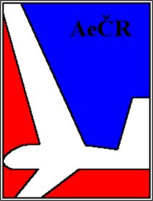
Entry Form for: 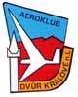
13th Czech Junior‘s Open National Gliding Championship 2005
SAFARI Cup – Open Class

Dvůr Králové nad Labem 9.7.2004 ÷ 23.7.2004

Pilot:
Name and surname: Date of birth:
NAC: ............................................................. Phone:
Postal Address (incl. Country):
E-mail: Mobile Phone:
Licence No.: Valid to:
Sailplane hours: Sailplane starts:
Sailplane hours in 2003: Km Cross-country:
FAI badges:
Glider:
Type: Registration: Contest No:
Class: Club Kombi
Ground crew:
Name and surname: Phone:
Postal Address (incl. Country):
Accommodation:
On the airfield AC Dvůr Králové: (Max. capacity 30-40 persons) yes no
Tent or Caravan (mobile home): yes no
Flight recorder:
GNSS FR: Type: ………………………….....

Date and pilot’s signature: Stamp of home AC, signature:

Please, return this Final Entry Form filled to the postal address AK Dvur Kralove, letiste, 544 01 Dvur Kralove, Czech Republic; or by e-mail to lkdk@atlas.cz, or by fax: +420 499 622 602.
The entry fee of EUR 200 per glider pay please by bank transfer to Ceska Sporitelna a.s., Czech Republic, Number of account 1301079319, Bank Code: 0800, or in cash to organizators. Please, return this form at the latest by the 8th July 2005.

